Connor Leu (ccl2396), Abdon Morales (am226923), Lauren Parker (lnp735)

Lab 2 - Pendulum Continued

Part 1
Method:
For Part 1, we decided to try and vary the masses attached to the pendulum to see if it impacts the period in any noticeable way. While there are other external factors that may vary the period (friction, human error), we believe that the mass of the weight has the most direct effect on how the pendulum swings over time.

Our pendulum is about 35.5 cm +/- 0.05 long and we are collecting data on the weights of 10g, 20g, 50g, 100g, 200g to determine if the mass changes the period. We predict that the heavier the mass, the larger the period.
When comparing our experiment design to another group, we had different approaches for how we planned to test our new hypotheses. Our group thought that the mass of the pendulum would impact the pendulum’s period, while our neighboring group thought that the model was simply incorrect. Although our hypotheses were different, both groups aimed to collect more data on more runs than the previous experiment last week, in hopes of obtaining more precise results.

Data:
For each mass, we logged 4 periods and averaged them per angle tested. The chart below contains all of the period data, followed by a visual graph.

Time error +/- 0.01s
 | Angle (°)
Mass (g) | 10 | 15 | 20 | 25 | 30
10 | 1.26 | 1.2475 | 1.245 | 1.27 | 1.27
20 | 1.26 | 1.26 | 1.27 | 1.2675 | 1.28
50 | 1.275 | 1.28 | 1.2825 | 1.29 | 1.29
100 | 1.28 | 1.28 | 1.29 | 1.3 | 1.3
200 | 1.29 | 1.2875 | 1.295 | 1.3 | 1.31

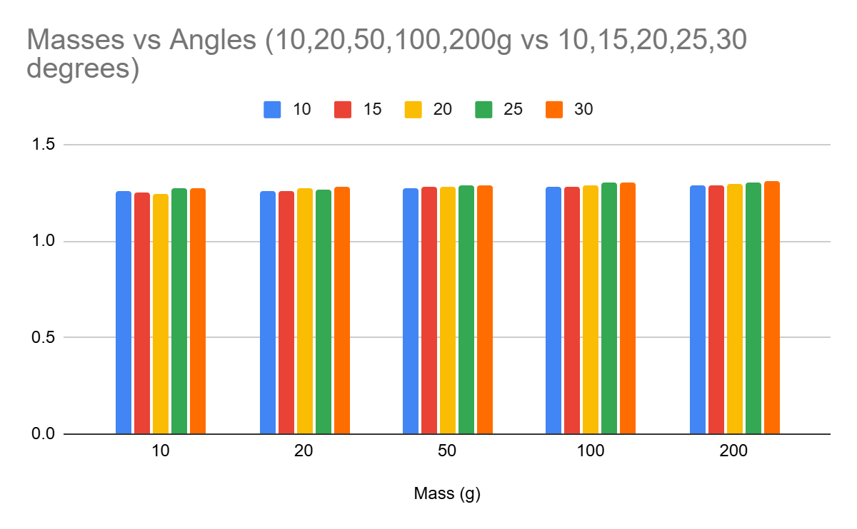
Conclusion
We conclude that the mass does not significantly contribute to the pendulum period, which contradicts our initial hypothesis that the mass of the pendulum would impact the pendulum period. As displayed in the chart above, we have a slight general upwards trend with both the masses and the angles, where the larger masses/ larger angle from which the pendulum has swung lead to higher periods.

The range of values obtained when altering the masses being swung from the pendulum had a far smaller range of values than the values we attained last week, where we kept the mass of 20g. Due to the measurements, we aren’t sure if it was the angle or the mass that more impacted the pendulum time; as such, we will be testing the angle in Part 2.

Part 2
Method
Due to our conclusions obtained from part 1, we will be testing the angle of the pendulum to determine if that impacts the period more. Our data from part 1 tells us that one of the two (mass or angle) impacts the period.

Due to the lack of variance by changing our masses from Part 1, we are going to fix the weight for this part (50g), and vary the angle significantly. We think that the equation for the period of a pendulum should take into account the angle being dropped from.

Data
We measured the averaged period of 4 measurements per angle, in increments of 5 degrees, from 15 to 60 degrees. The following chart highlights the data:

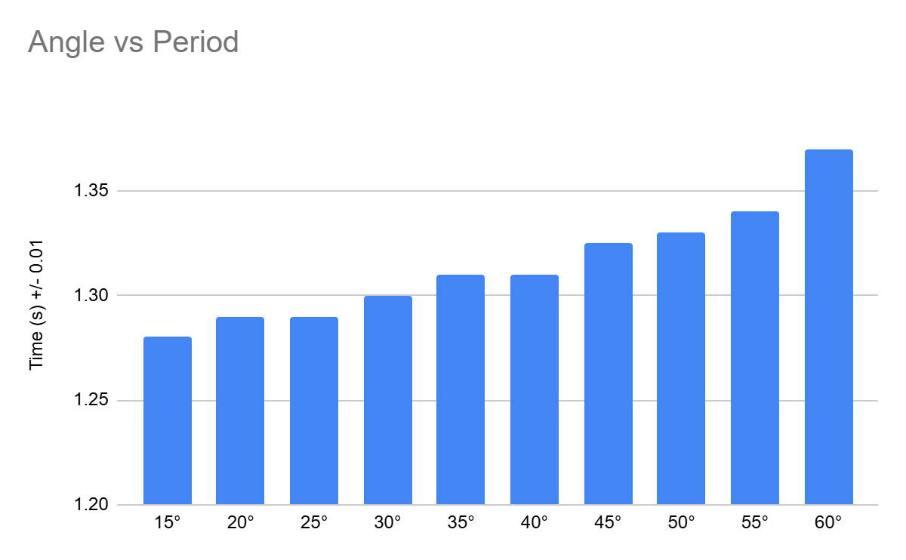
As we can see from the graph, the angle the pendulum is swinging from does notably impact the period. We believe that the pendulum equation should take the angle into account as a primary factor, scaled by some constant, turning it to look like:
$T=2π*αθ*\sqrt{\frac{l}{g}}$
The angle should be considered in radians to keep with standard units. We did not collect enough data to accurately come up with a value for our scaling factor alpha, but due to the angle’s direct impact on the pendulum time, higher values of theta should directly increase T, hence it not being under the square root.

As an aside: there exists the elliptic integral solution for pendulums, which does this exact thing! But with a lot more math. We found a write up at this link. Cool stuff.

Conclusion:
We conclude that angle has a significant impact on the pendulum’s period. After swinging a 20g mass at varying angle lengths from 15° to 60°, we obtained pendulum periods from 1.28s to 1.37s (+/-0.05s uncertainty). Compared to the experiment that we conducted in Part 1, this wider range of values indicates the greater impact of the angle the pendulum is swung from in comparison to the pendulum’s mass.
Additionally, we noted that the larger the angle from which the pendulum has swung, the period values varied more. For example, when swinging the pendulum from 15°, all 4 periods of the run were 1.28s, while when swung from 55°, the 4 periods of the runs were 1.32s, 1.35s, 1.35s, and 1.34s. The variations in these values could be attributed to general uncertainty, but given the upward trend in period times we strongly believe that this is due to the impact angle has on period.
This experiment could be improved with better equipment for testing, as well as taking more samples per angle. This would give us more data to better compute any error as well as the impact angle had on the period.

